**Issue:**

Tim, a sales representative, has been able to view all opportunities, leads, referrals, contacts, and records of other objects regardless of ownership.

Jose as Sales Manager should see records of all sales staff. sales staff should only see records they own.

**Opportunity screenshot:**

**Lead referral screenshot:**

**Contact screenshot:**

Tim has access to see a few more objects too.

**Investigation:**

* Both Tim and Jose share the **same profile,** "Standard Sales User," which inherently grants "View All" and "Modify All" access to all objects.
* The role hierarchy appears correct, with Jose positioned appropriately under the Manager Salesman role (ERISA role).

**Solution:**

To address the issue:

**1.Profile-Level Permissions Adjustment:**

* Removed "View All" and "Modify All" access from the "Standard Sales User" profile for all objects.

**2.Permission Set Creation:**

* Created a permission set specifically for Jose, the manager, granting him explicit "View All" and "Modify All" access to all relevant objects. This ensures Jose can oversee all records, including those owned by sales representatives like Tim

**Impact of Removing Permissions:**

* If you remove the "View All" or "Modify All" permissions for leads from a user’s profile or permission set, it can restrict their ability to convert leads. This is because they won’t be able to see or edit certain leads, which are prerequisites for converting them.

**Enablement of Convert Lead Option:**

* Enabled the "Convert Lead" permission in the profile settings to allow Tim and other sales representatives to convert leads despite the restricted view permissions. This ensures business processes like lead conversion remain functional.

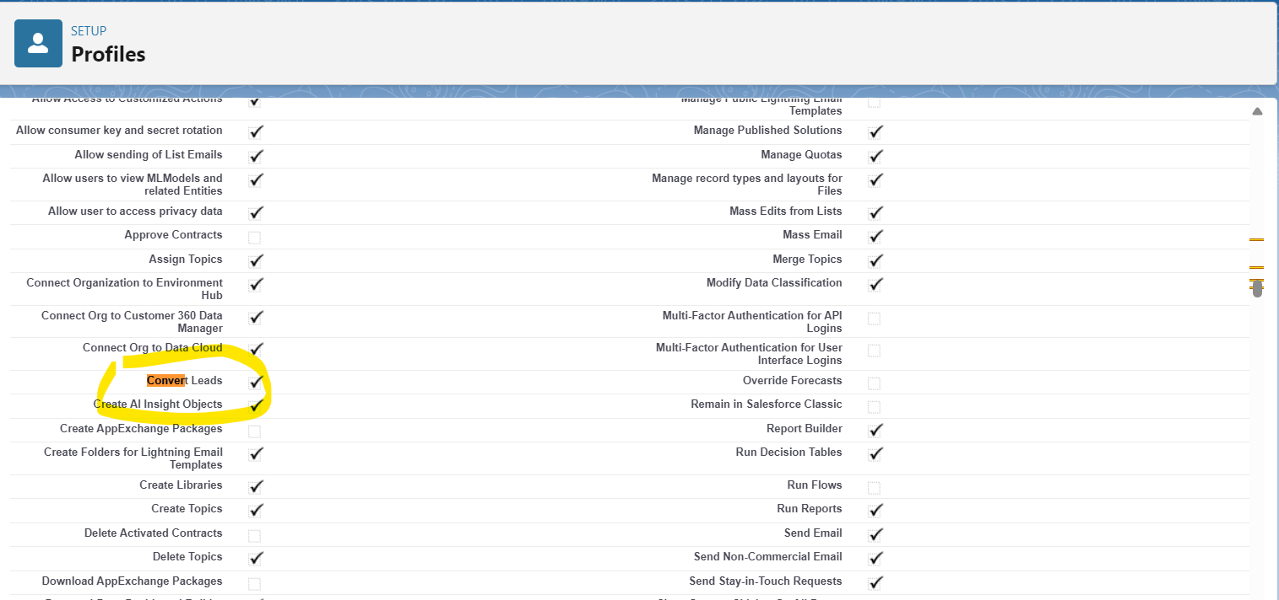

**Conclusion:**

By adjusting profile-level permissions and creating targeted permission sets, we have successfully aligned access controls with organizational requirements. This approach ensures that data visibility and management capabilities are appropriately distributed across roles while preserving operational functionalities such as lead conversion. Moving forward, maintaining a clear distinction between profile settings and permission sets will uphold data integrity and operational efficiency within Salesforce.

Finally now in production Tim can see only his won records where Jose can his own records as well as sales staff records.